**ASSIGNMENT 4 (12-03-2024)**

1. Create table Department114(Dept_id varchar2(3) primary key,Dept_name varchar2(15));

desc Department114;

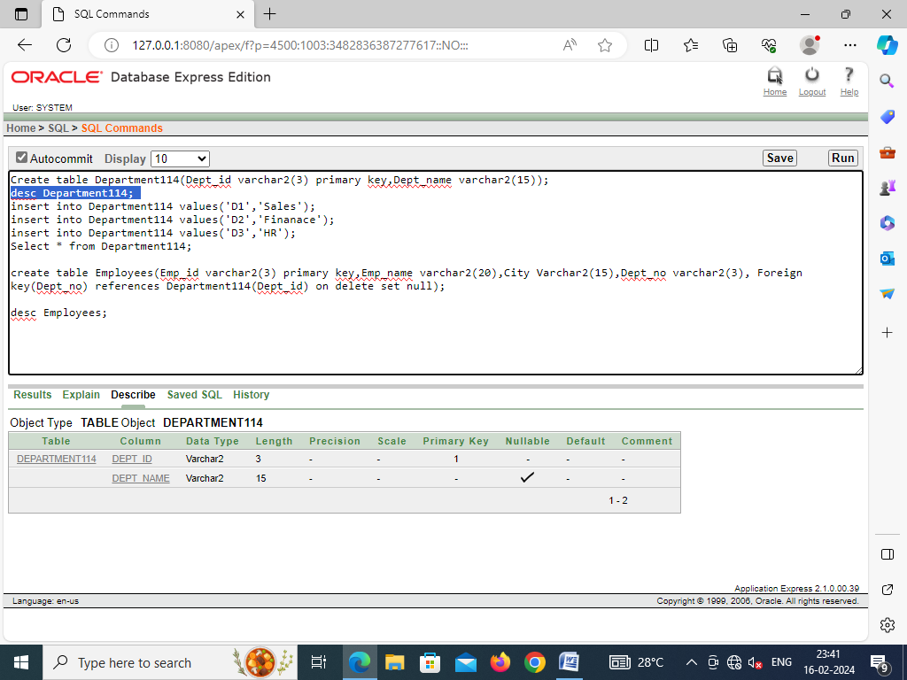

1. insert into Department114 values('D1','Sales');

insert into Department114 values('D2','Finanace');

insert into Department114 values('D3','HR');

Select * from Department114;

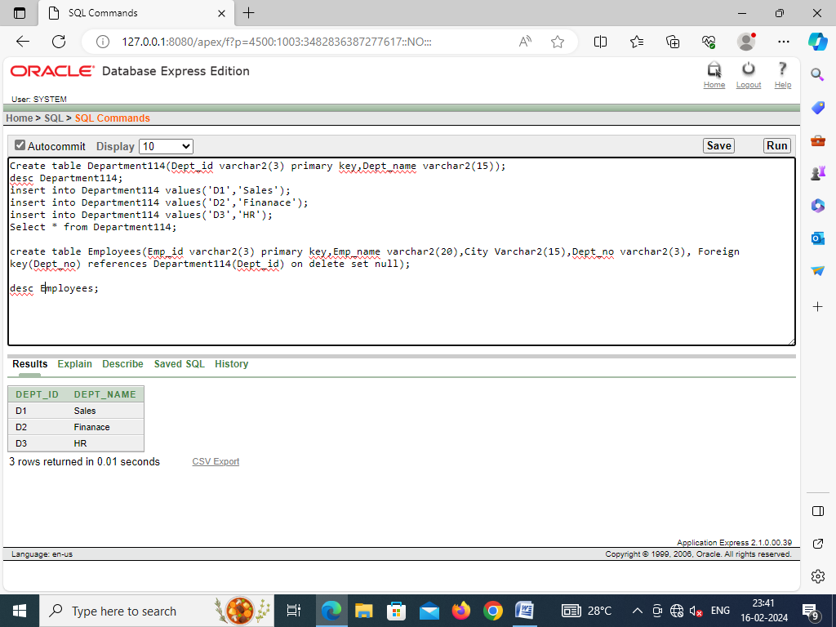

1. create table Employees(Emp_id varchar2(3) primary key,Emp_name varchar2(20),City Varchar2(15),Dept_no varchar2(3), Foreign key(Dept_no) references Department114(Dept_id) on delete set null);

desc Employees;

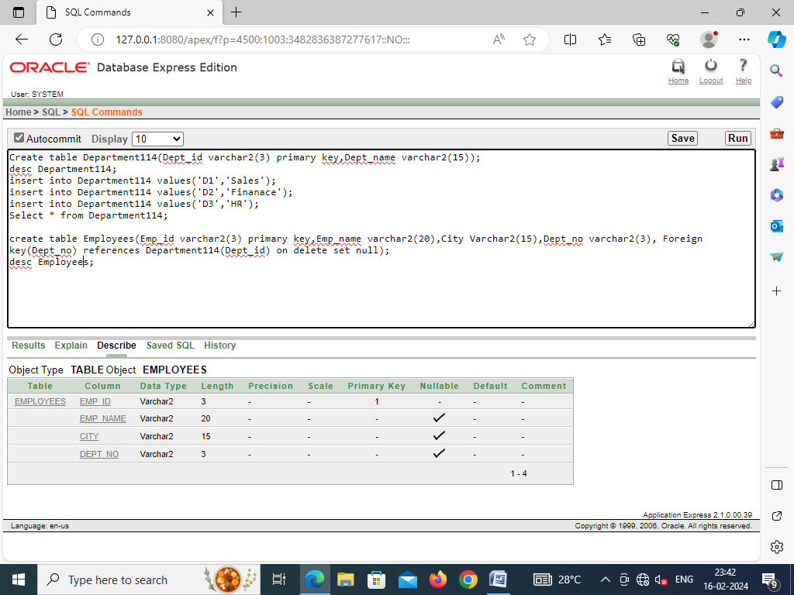

1. insert into Employees values('E01' , 'Nishita', 'Delhi', 'D1');

insert into Employees values('E02' , 'Vaishnavi', 'Kolkata', 'D3');

insert into Employees values('E03' , 'Avyaya', 'Mumbai', 'D1');

insert into Employees values('E04' , 'Gulshan', 'Kolkata', 'D2');

insert into Employees values('E05' , 'Rishabh', 'Delhi', 'D3');

insert into Employees values('E06' , 'Ayush', 'Mumbai', 'D3');

insert into Employees values('E07' , 'Anjali', 'Mumbai', 'D2');

Select * from Employees;

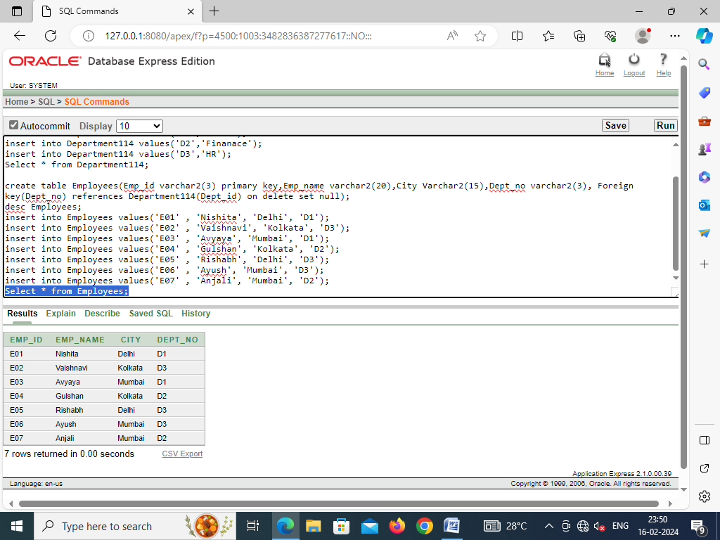

1. Select constraint_name,constraint_type from user_constraints where table_name = 'EMPLOYEES';

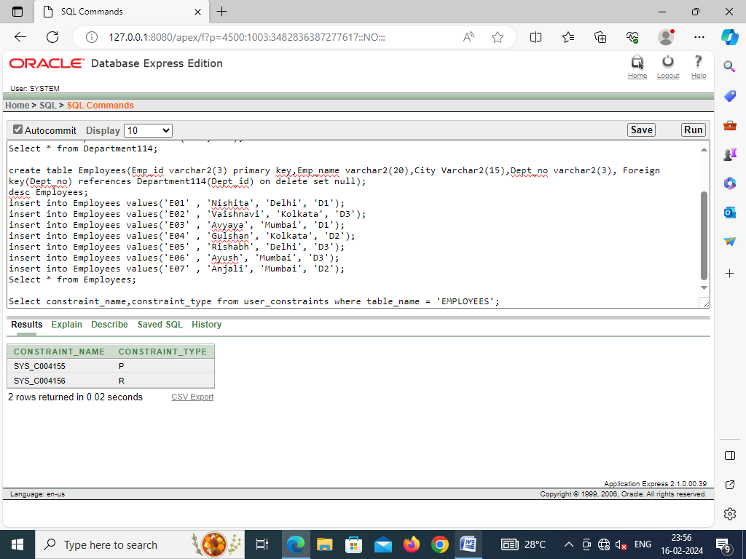

1. drop table Department114;

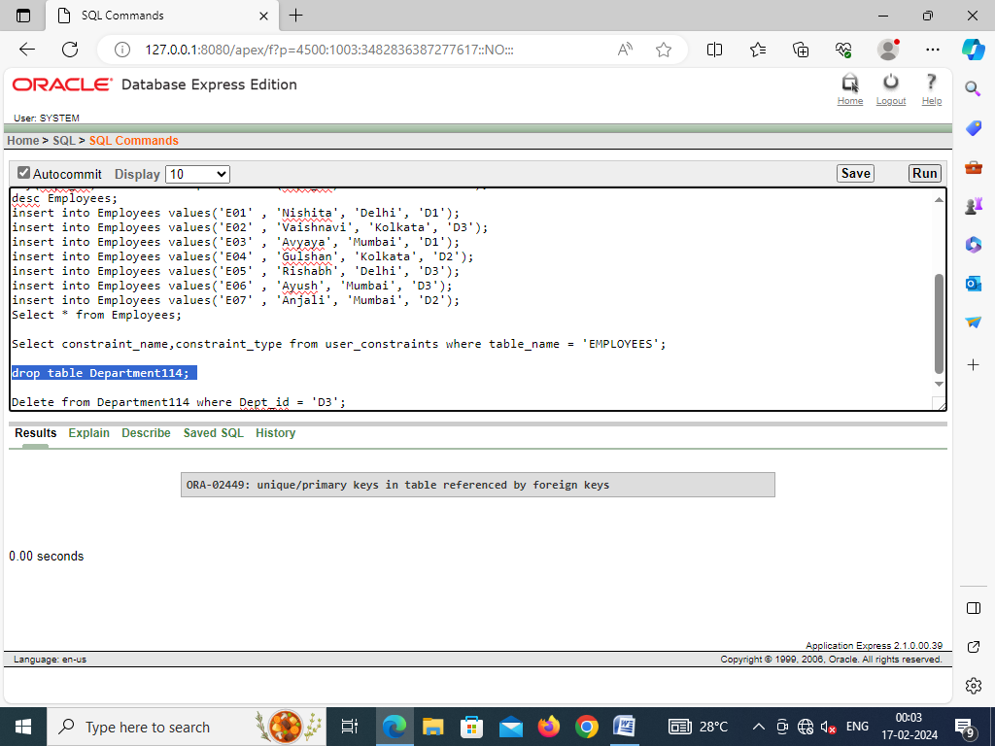

1. Delete from Department114 where Dept_id = 'D3';

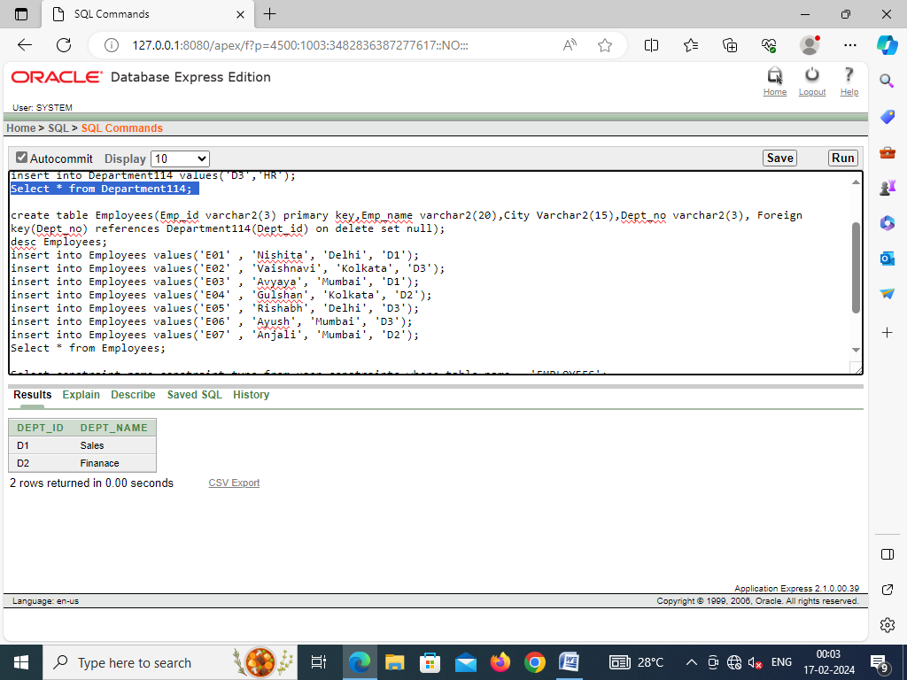 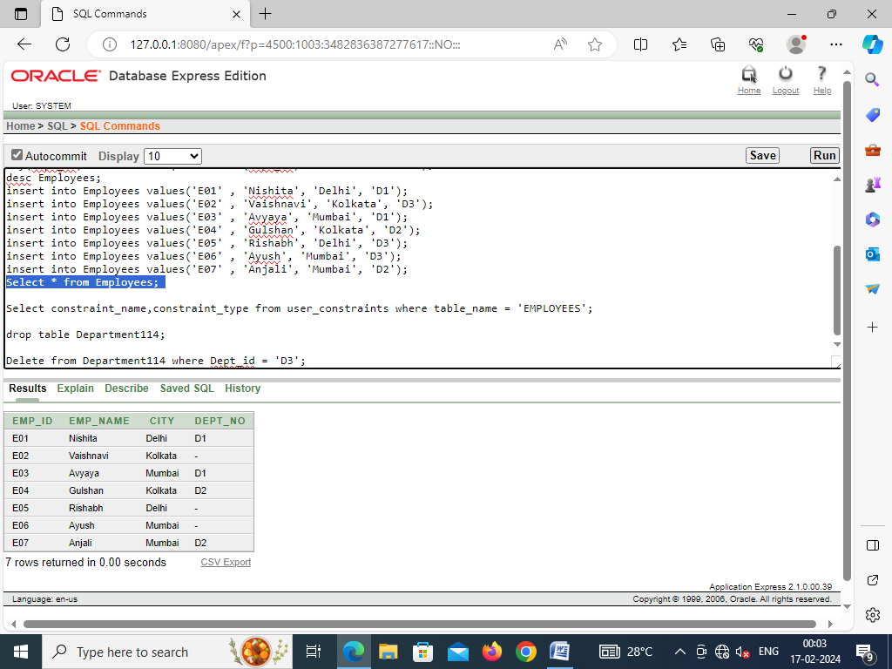

1. Drop table Employees;

create table Employees(Emp_id varchar2(3) primary key,Emp_name varchar2(20),City Varchar2(15),Dept_no varchar2(3), Foreign key(Dept_no) references Department114(Dept_id) on delete cascade);

desc Employees;

insert into Employees values('E01' , 'Nishita', 'Delhi', 'D1');

insert into Employees values('E02' , 'Vaishnavi', 'Kolkata', 'D3');

insert into Employees values('E03' , 'Avyaya', 'Mumbai', 'D1');

insert into Employees values('E04' , 'Gulshan', 'Kolkata', 'D2');

insert into Employees values('E05' , 'Rishabh', 'Delhi', 'D3');

insert into Employees values('E06' , 'Ayush', 'Mumbai', 'D3');

insert into Employees values('E07' , 'Anjali', 'Mumbai', 'D2');

delete from Department114 where Dept_id = 'D3';

